Internet Intelligence

Keep passwords to yourself. Don’t share any personal information (name, city, age, phone, address, etc.).

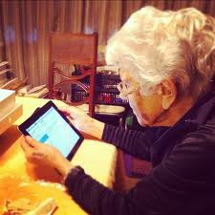
Would you want someone to write that about you?
Would your grandma want to read or see that?

Cite Your Source (Give ‘em Mad Props)

RESPECT OTHERS. It’s just simply tender.

